**TOC Unit 2**

1. Define Regular Grammar and explain its types with examples.

Definition :-

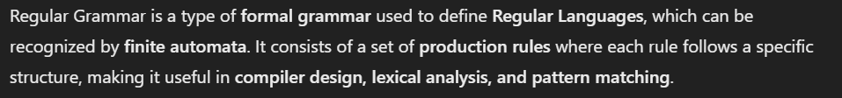

Types of Regular Grammer :- It is classified in two types,

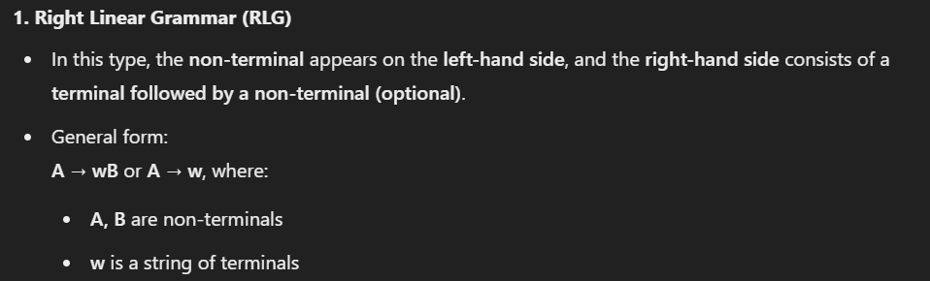

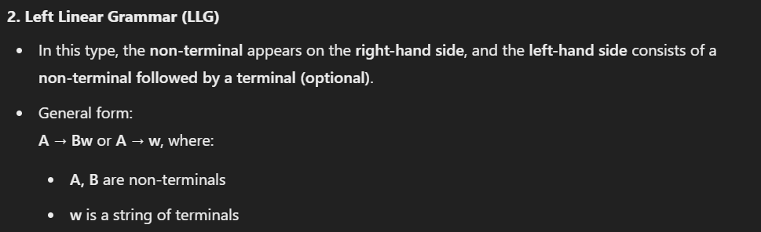

2. What are Regular Expressions? Write regular expressions for the language of all binary strings ending with '01'.

Definition of Regular Expressions :-

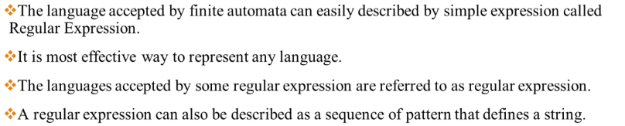

Regular Expression for the language of all binary strings ending with ‘01’ :-

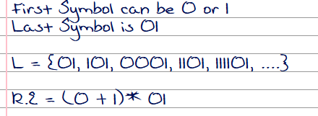

3. Explain the relationship between Finite Automata and Regular Expressions.

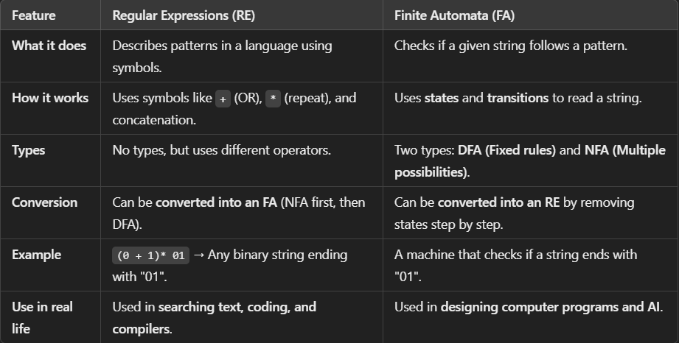

4. State and explain the Pumping Lemma for Regular Languages with an example.

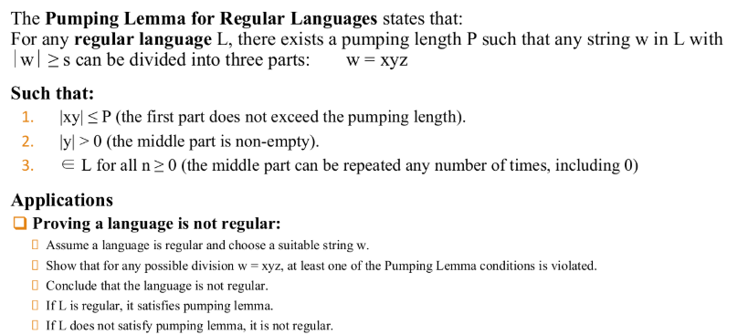

Example :-

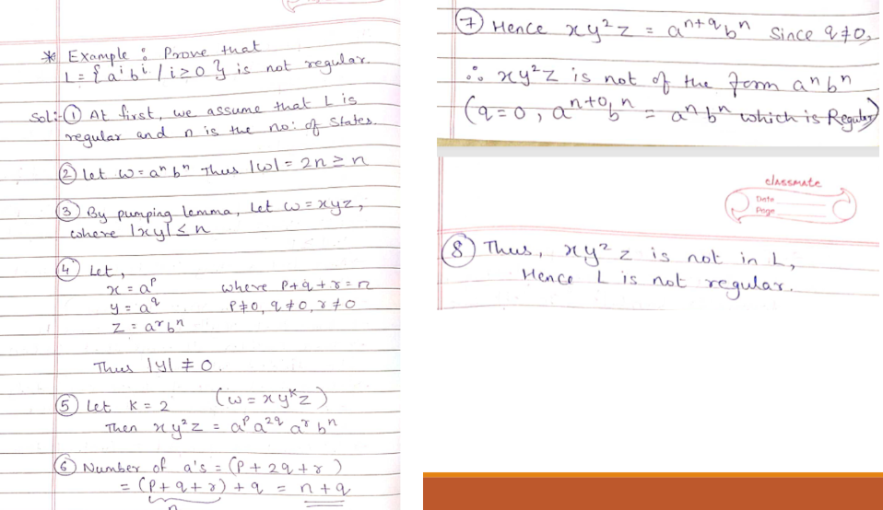

5. Discuss the closure properties of Regular Sets with examples.

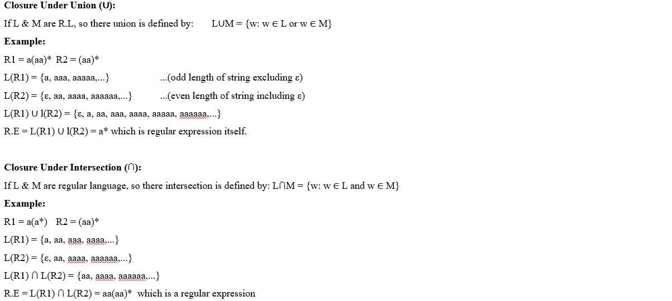

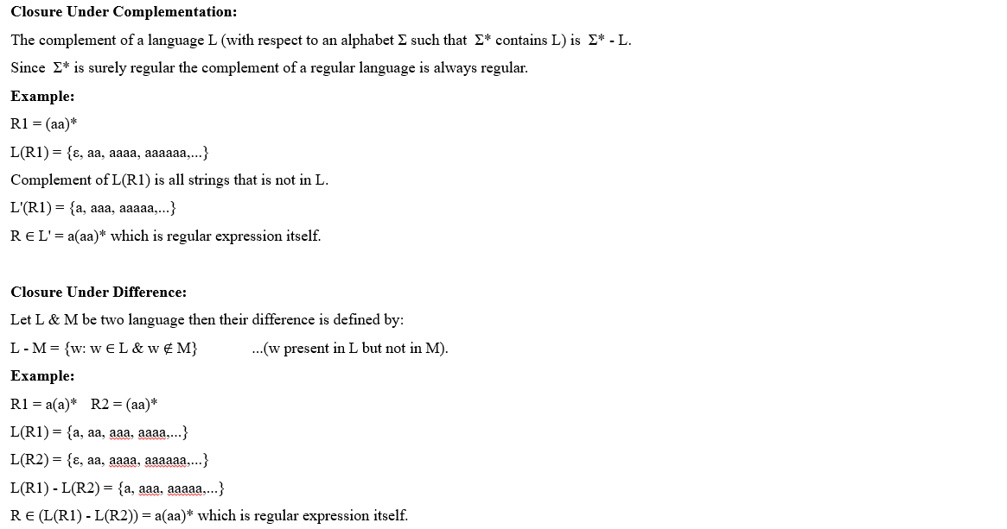

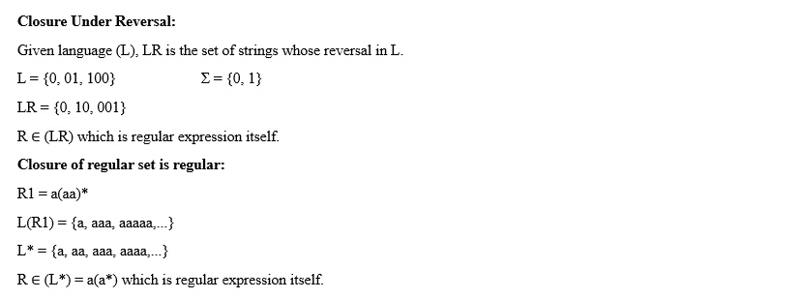

6. Write the Regular Expression for the given conditions :-

a) Write R.E for the language accepting all string containing any number of a's & b’s.



b) Write R.E for the language accepting all the string which are starting with 1 & ending with 0, over Σ = {0, 1}.

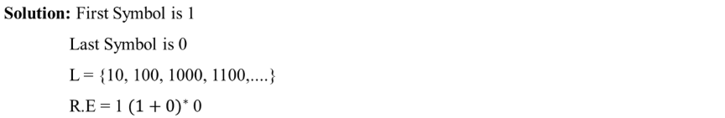

c) Write R.E for the language starting with 'a' but not having consecutive b's.



d) Write the R.E for the language over Σ = {0} having even length of the string.



e) Write the R.E for the language L over Σ = {0, 1} such that all the string do not contain the substring 01.



7. Convert the Regular Expression in to Finite Automata :-

a) Design a FA from given regular expression ba*b.

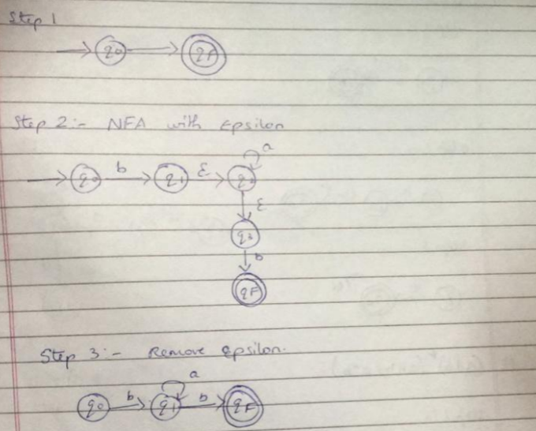

b) Design a FA from given regular expression (a + b)c.

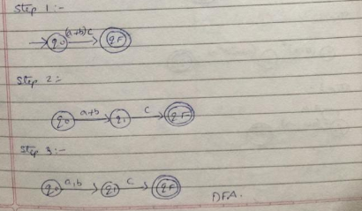

c) Design a FA from given regular expression a(bc)*.

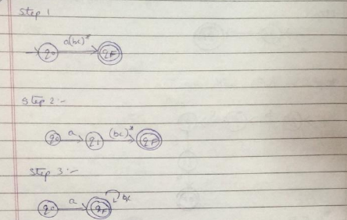

d) Design a FA from given regular expression (a | b)*(abb | a*b)

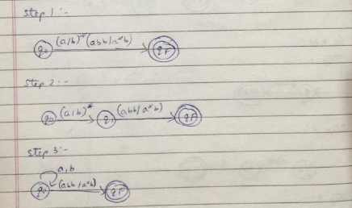

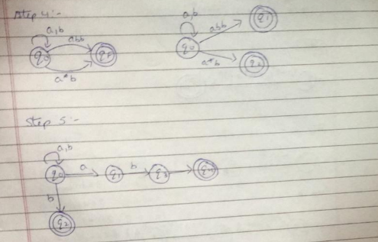

e) Design a FA from given regular expression (0 + 1)*(00 + 11)(0 + 1)*

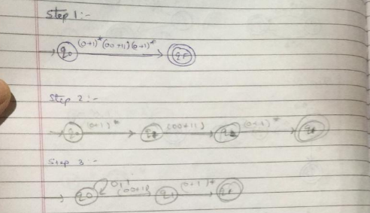

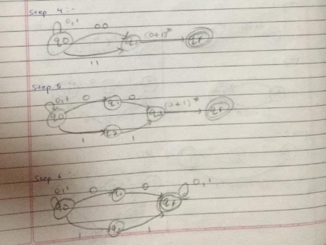

f) Design a FA from given regular expression 10 + (0 + 11)0* 1.

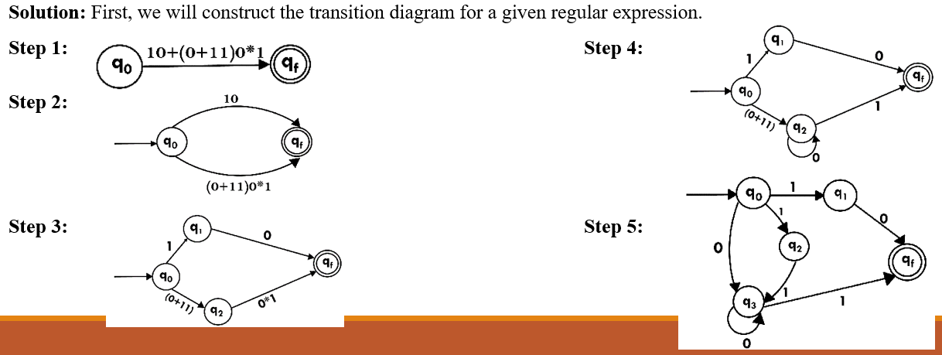

g) Design a NFA from given regular expression 1 (1* 01* 01*)*.

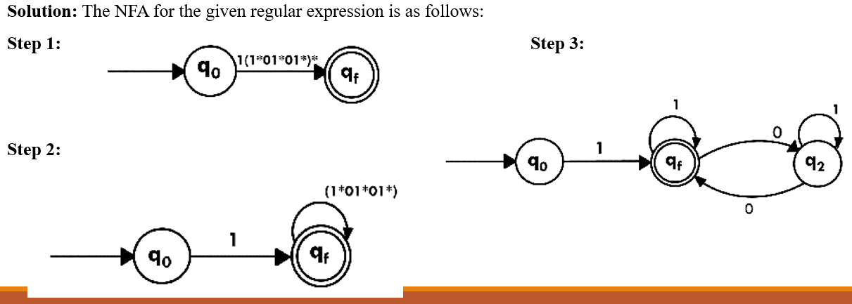

h) Construct the NFA for regular expression 0*1 + 10.

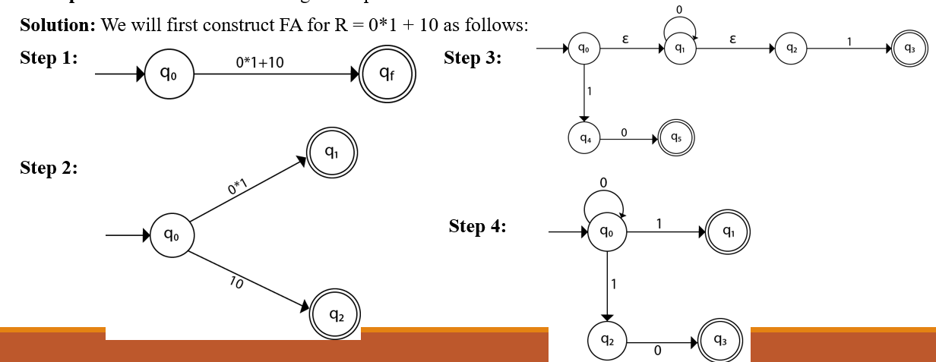

8. List the rules of conversion Regular Expression into Finite Automata. (All 13 Rules)

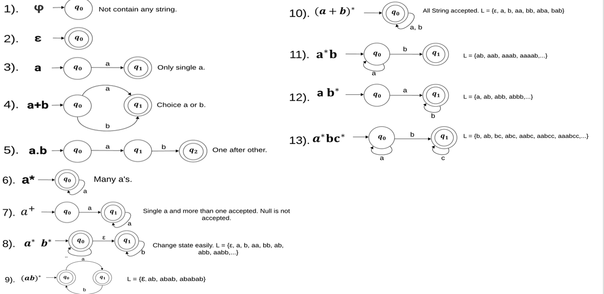

9. Define the following terms :-

a) Closure under Union

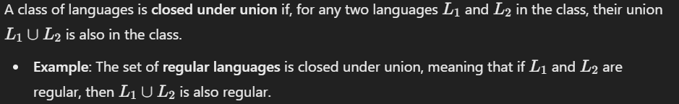

b) Closure under Intersection

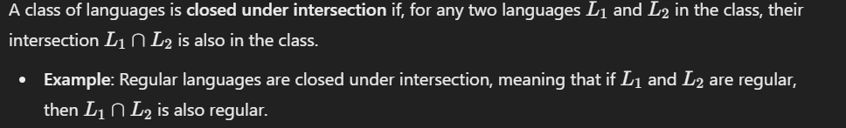

c) Closure under Complementation

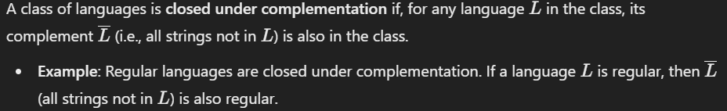

d) Closure under Difference

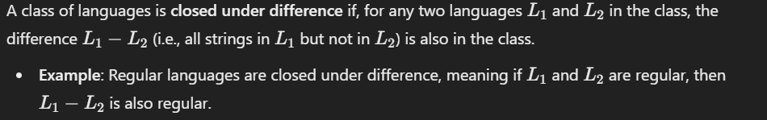

e) Closure under Reversal

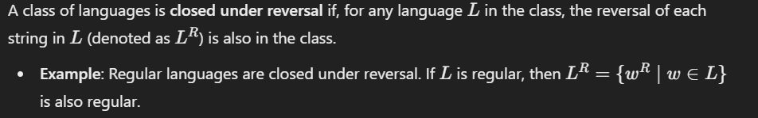

10. What are the applications of Pumping Lemma for Regular Grammar.

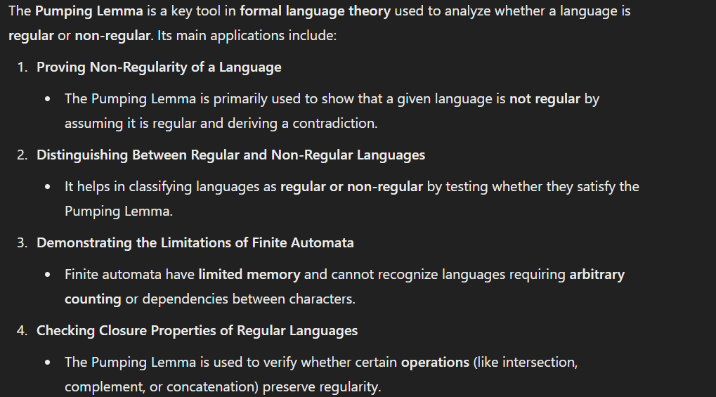

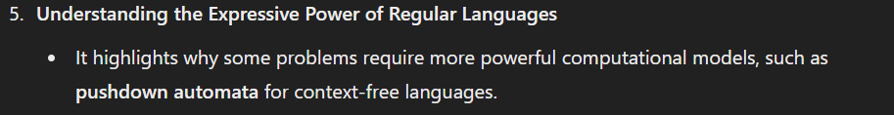

11. Define Context-Free Languages (CFLs) and give an example.

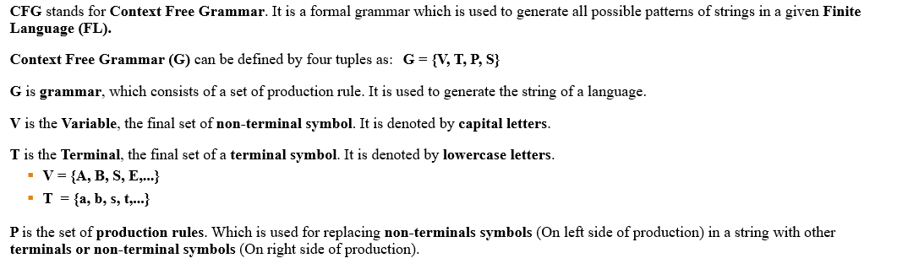

Example :-

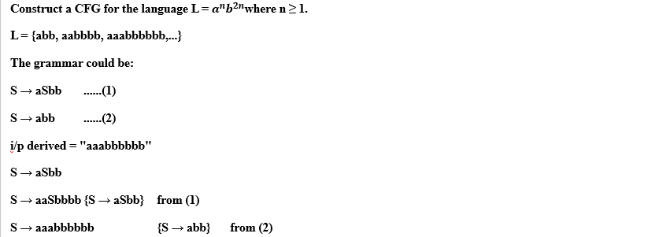



12. What is a Derivation Tree (Parse Tree)? Explain with an example.

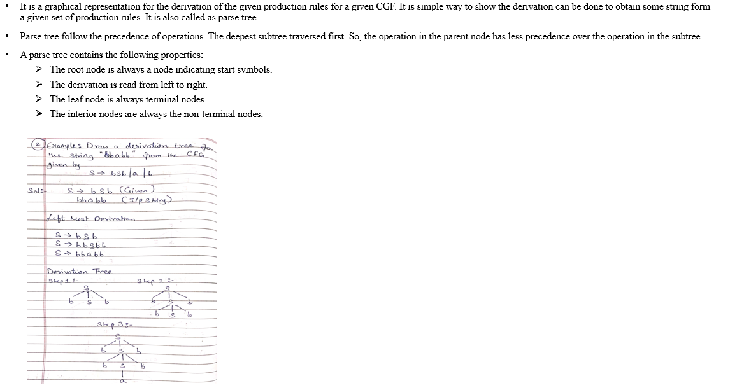

13. Explain Ambiguity in Grammar with an example.

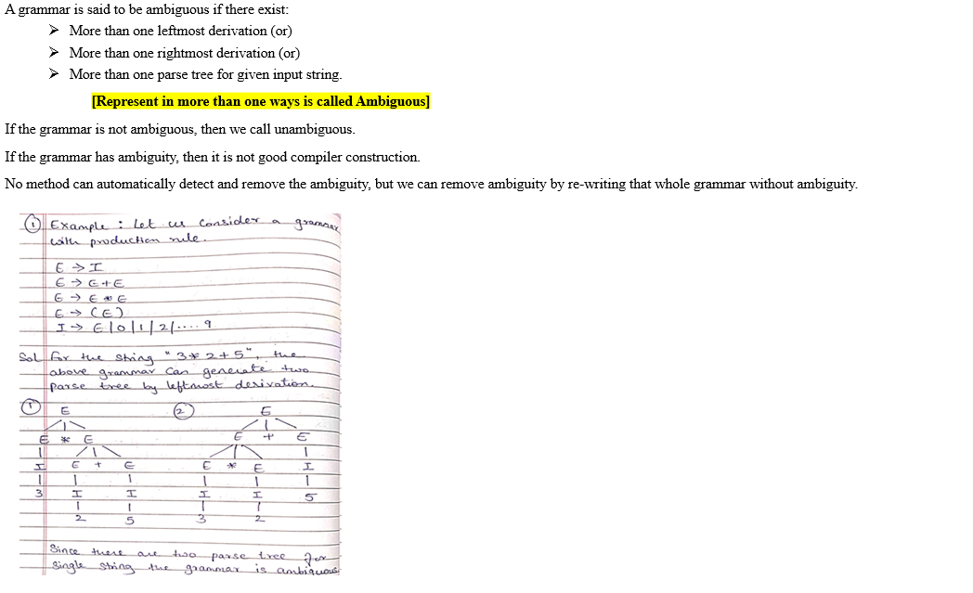



14. State and explain the Pumping Lemma for Context-Free Languages with an example.

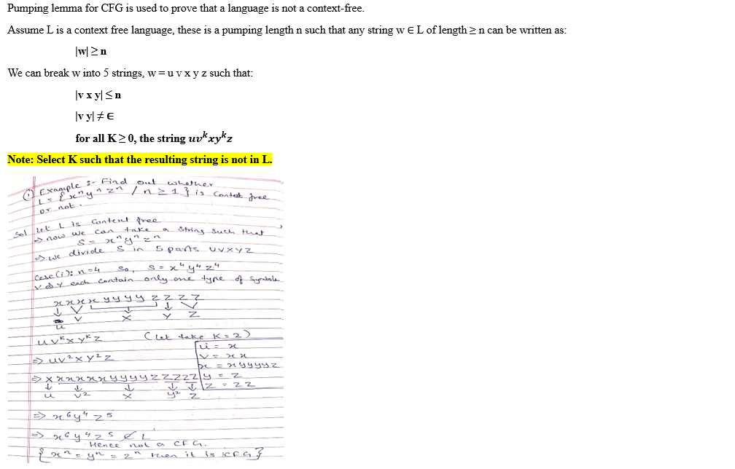

15. Examples – Construct a CFG :-

a) Construct CFG for the language having any no. of a's over the set Σ = {a}.

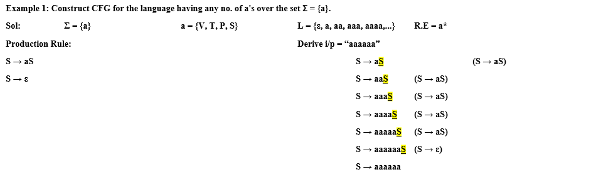

b) Construct a CFG for language L = {WCWR | where W ∈ (a, b)*}.

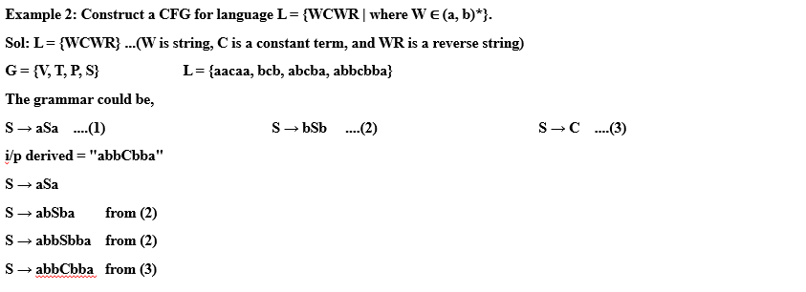

c) Construct a CFG for the language L = a^nb^2n where n ≥ 1.

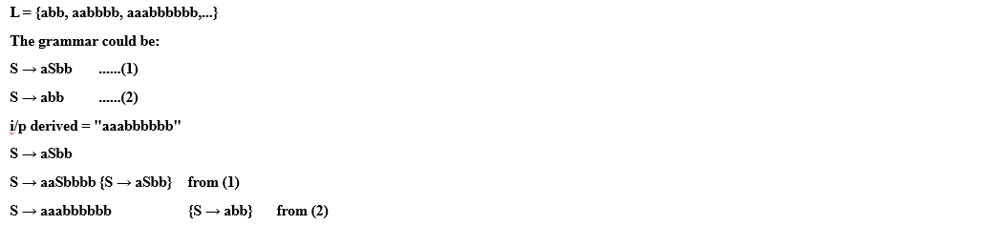

d) Consider a context free grammar G with the following productions:

S → ASA | B B → aCb | bCa C → ACA | A A → a | b | ε

Find the following :-

(i) What is the variable in G :- S, B, C, A

(ii) What are the terminals of G :- a,b

(iii) Give strings of length 7 in L(G).

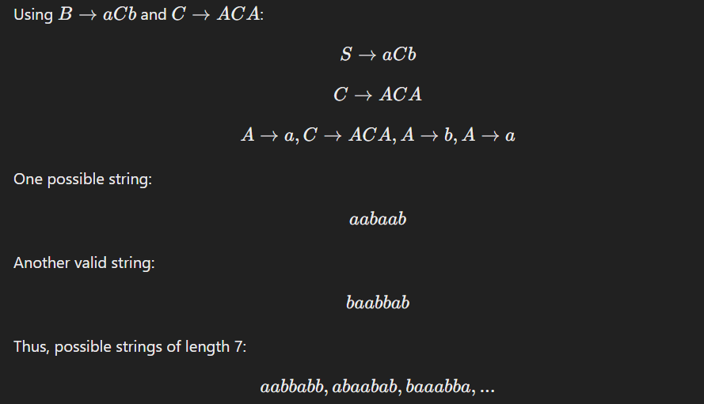

(iv) Give strings of length 5 in L(G).

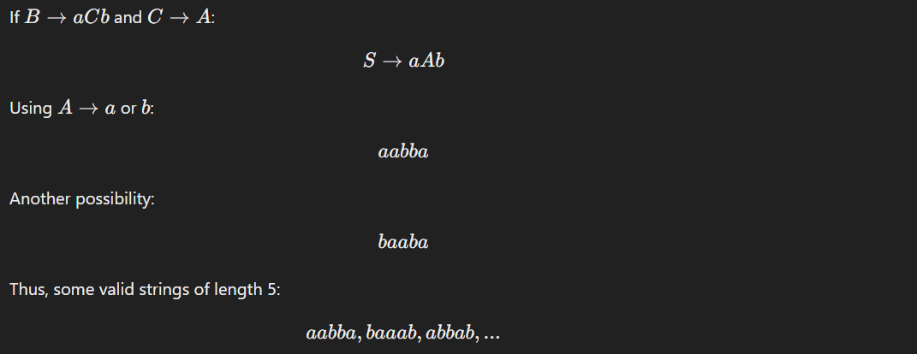



(v) Give strings of length 4 in L(G).

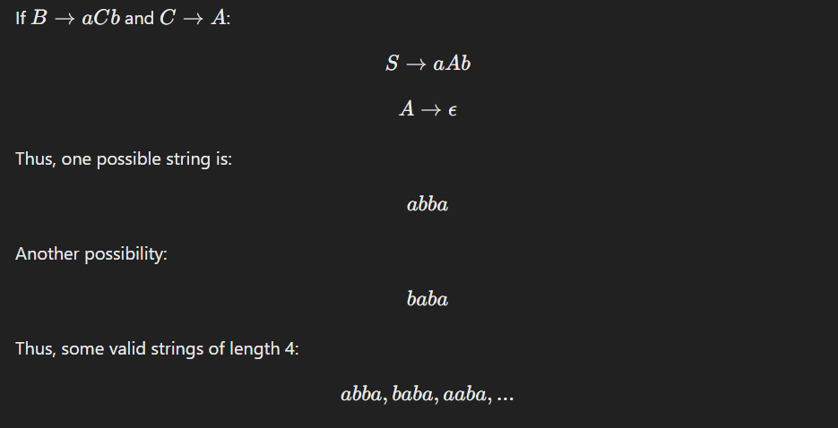

16. Examples – Left Most Derivation and Right Most Derivation :-

a) Find the left most & right most derivation for the given production rule.

S → AB/ε A → aB B → Sb

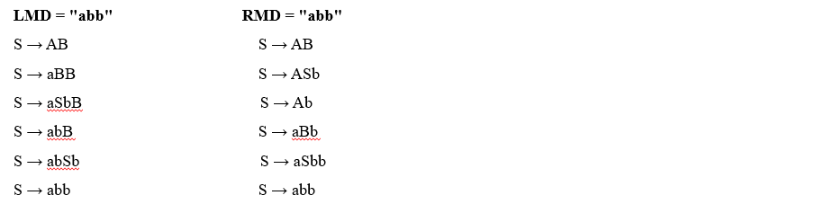

b) Derive the string "00101" for left most derivation and right most derivation using CFG given below :-

S → A1B A → 0A/ε B → 0B/1B/ε

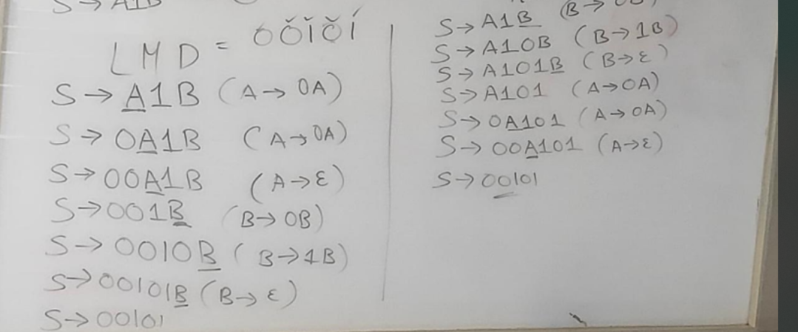

c) Derive the string "aabbabba" for left most derivation and right most derivation using CFG given below :-

S → aB/bA A → a/aS/bAA B → b/bS/aBB

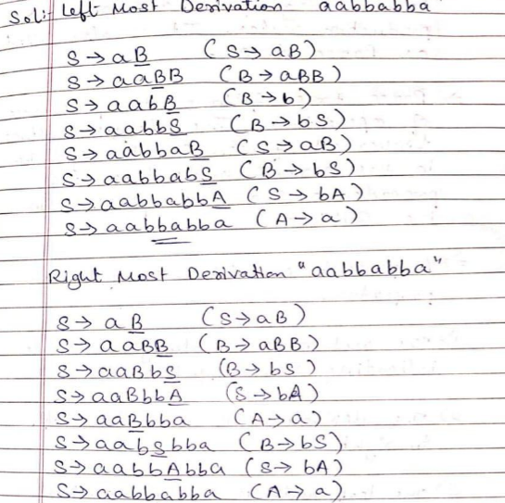

17. Examples – Derivation Tree :-

a) Let G = {(S, A), (a, b), P, S} where P consists of :-

S → aAS | a | SS A → SbA | ba

Draw a derivation tree.



b) Consider the grammar G whose productions are

S → aAS | a A → SbA | SS | ba

Show that S → aabbaa and construct a derivation tree.

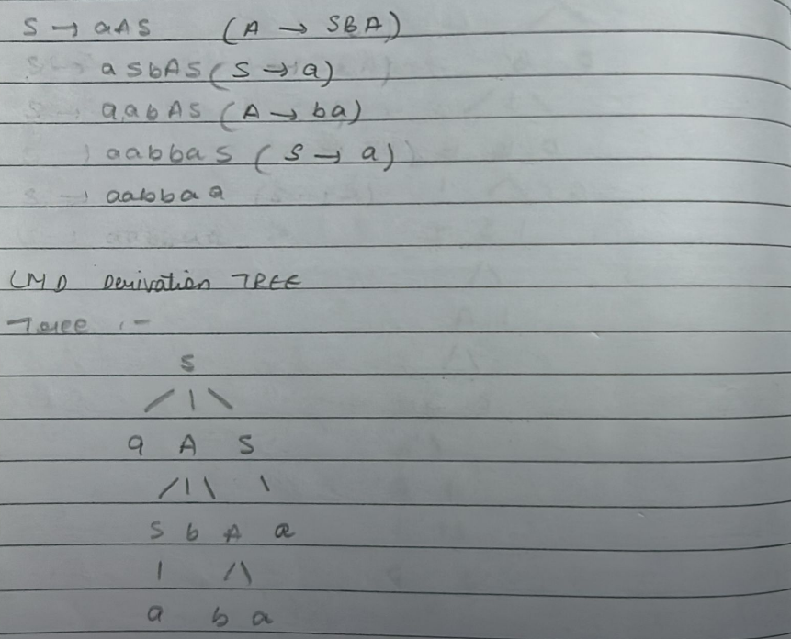

c) Draw a derivation tree for the string "bbabb" from the CFG given by :-

S → bSb | a | b

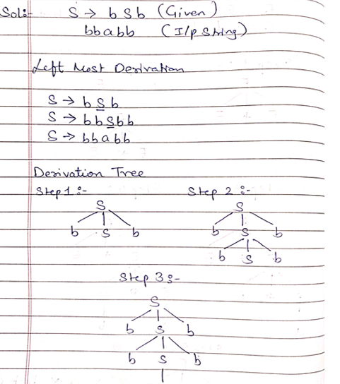



d) Consider the grammar G whose productions are :-

E = E + E

E = E * E

E = a | b | c

The given i/p String = a * b + c and construct a derivation tree.

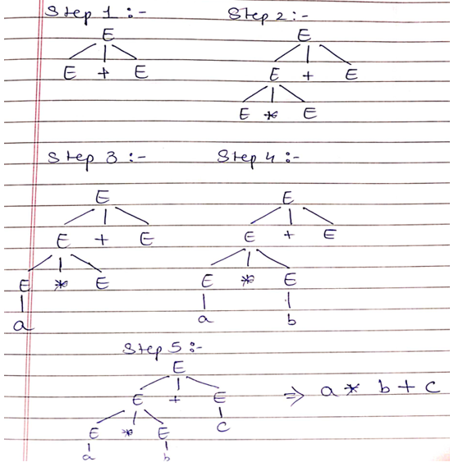



e) Construct a derivation tree for the string "aabbabba" for CFG by :-

S → aB | bA A → a | aS | bAA B → b | bS | aBB

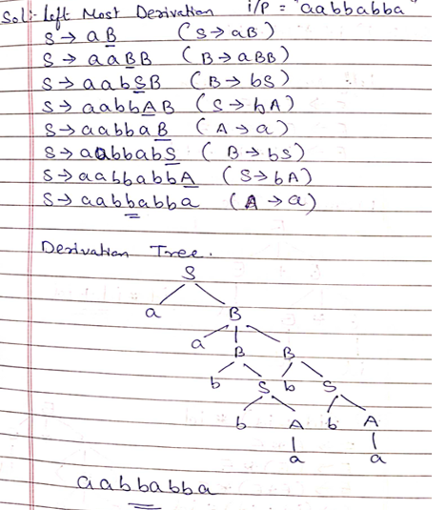

f) Consider the Grammar and obtain derivation tree of the given expression :-

E → E + E E → E * E E → (E) E → id

Find the following: (i) id * id + id & (ii) (id + id) * id

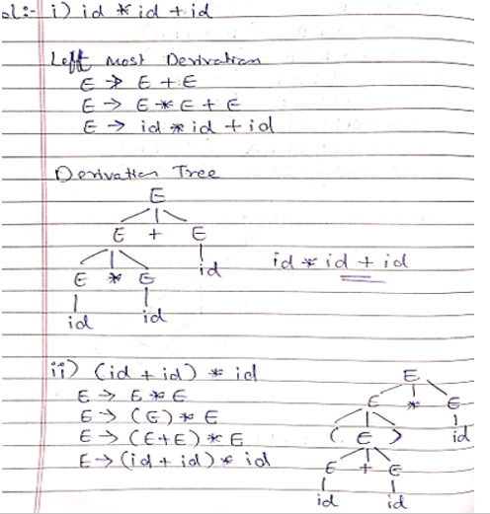

g) For generating string aabaa from the given grammar using left derivation method and construct a derivation tree.

S → aAS | aSS | ε A → SbA | ba

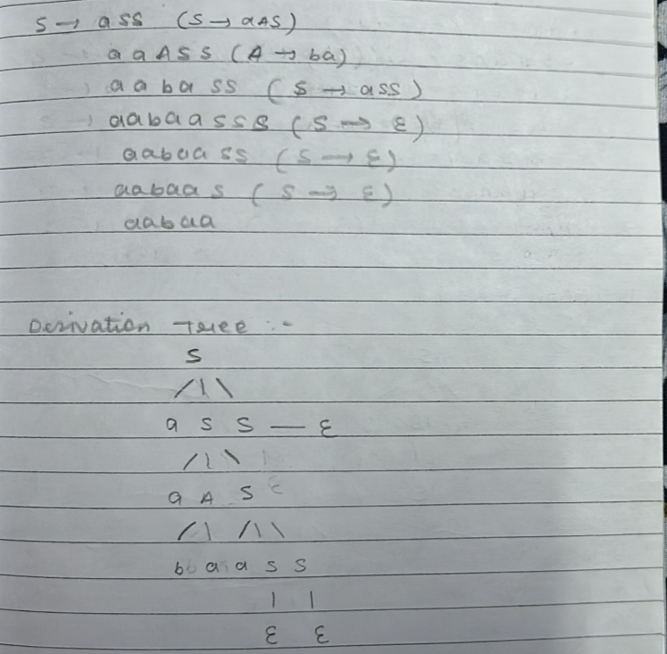



h) For generating string aabaa from the given grammar using right derivation method and construct a derivation tree.

S → aAS | aSS | ε A → SbA | ba

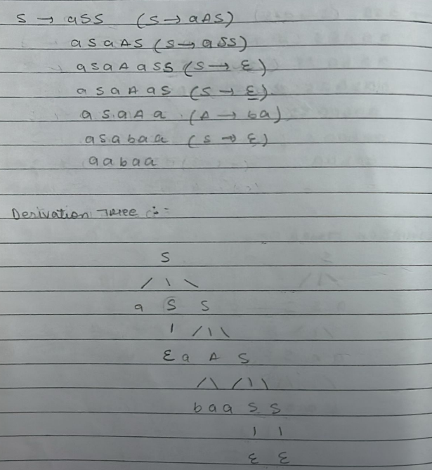

i) For generating string 00110101 from grammar,

S → 0B | 1A

A → 0 | 0S | 1AA

B → 1 | 1S | 0BB

Find the following :-

(i) Left most derivation tree

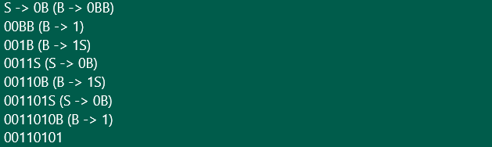

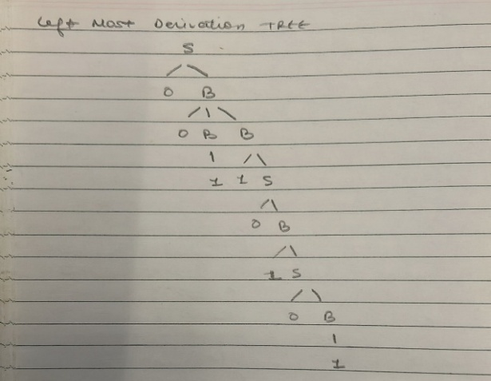

(ii) Right most derivation tree

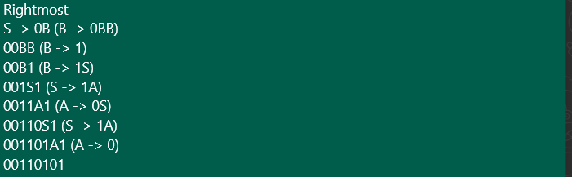

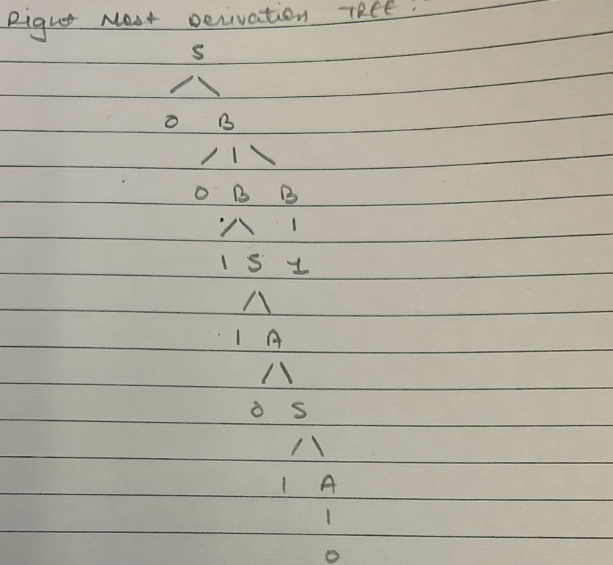

j) Consider the following productions :-

S → aB | bA A → aS | bAA | a B → bS | aBB | b

For the string aaabbabbba find the following :-

(i) Left Most Derivation

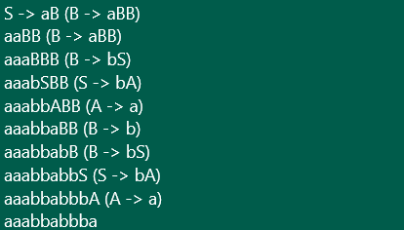



(ii) Right Most Derivation

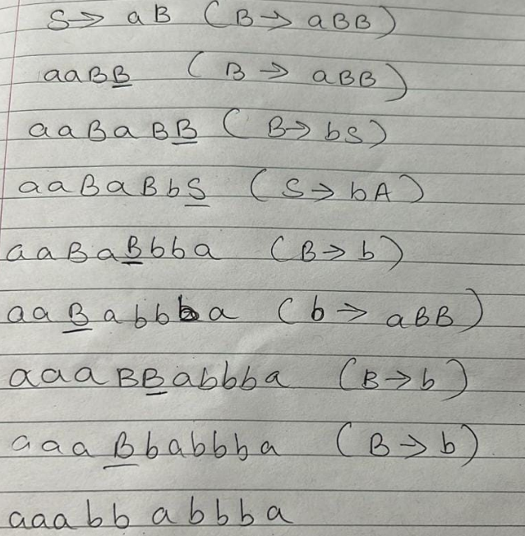

(iii)Parse Tree

LMD Tree :-

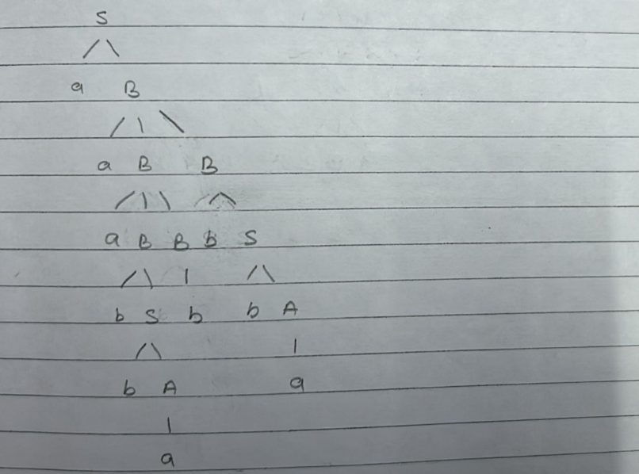

RMD Tree :-

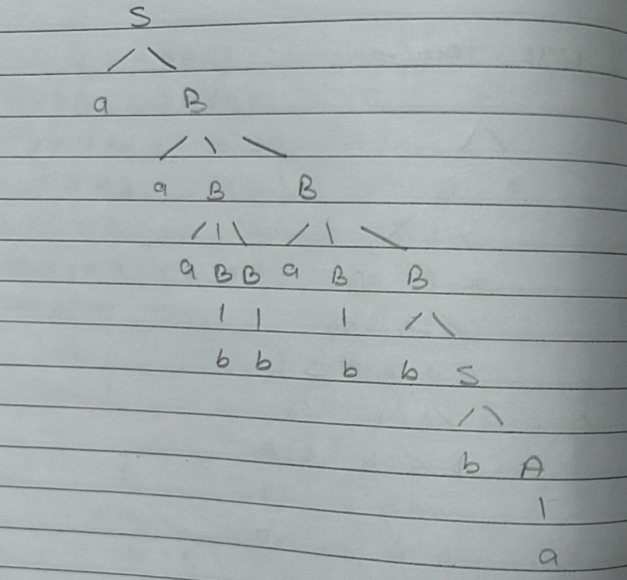

18. Explain the unambiguous of grammar with suitable example.

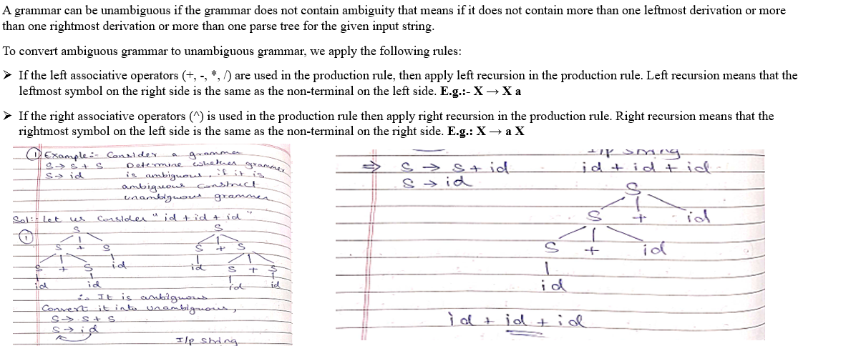

19. Examples - Check whether the given grammar is ambiguous or not :-

a) Let us consider a grammar with production rule.

E → I E → E + E E → E * E E → E

I → E | 0 | 1 | 2 |....9

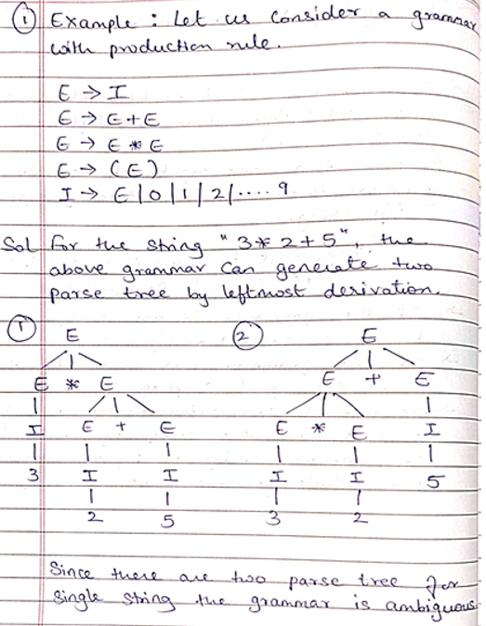

b) Check whether the grammar is ambiguous or not.

A → AA A → A A → a

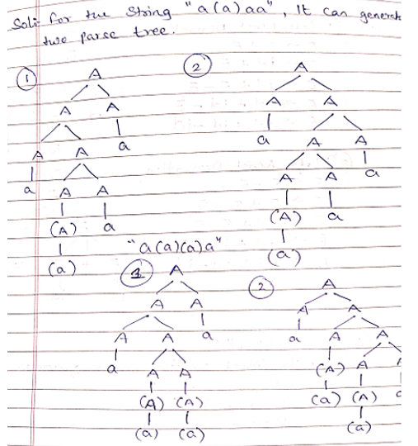

c) Check whether the given grammar is ambiguous or not.

E → E + E E → E – E E → id

i/p string = id + id – id

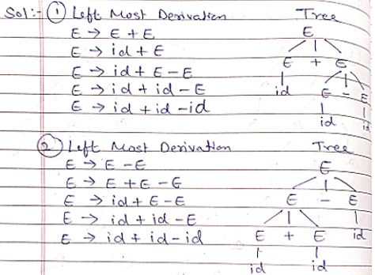

d) Check whether the given grammar is ambiguous or not.

S → aSb | SS S → E

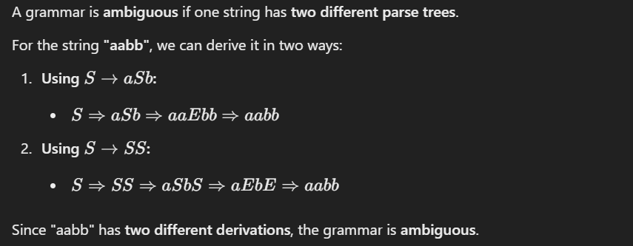

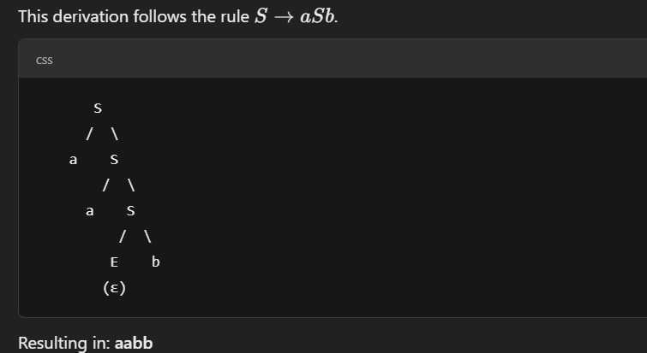



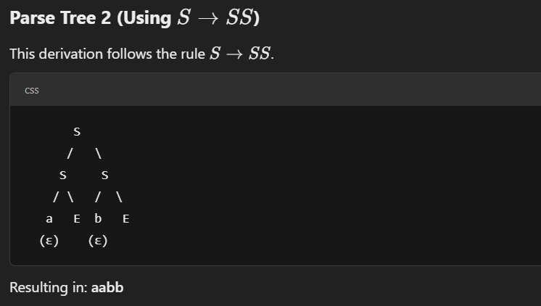



e) Check whether the given grammar is ambiguous or not.

S → SbS | a

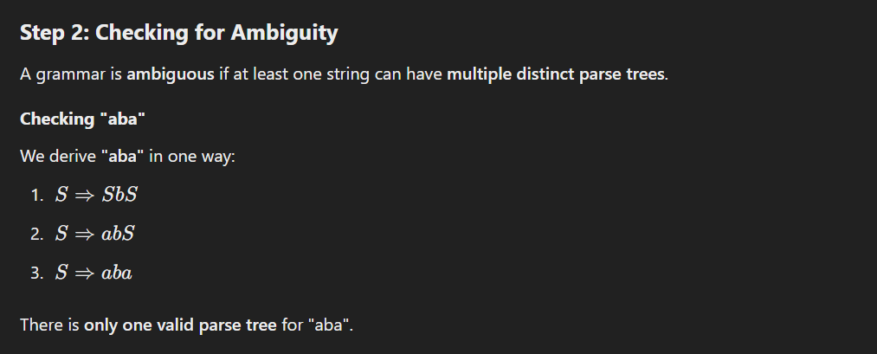



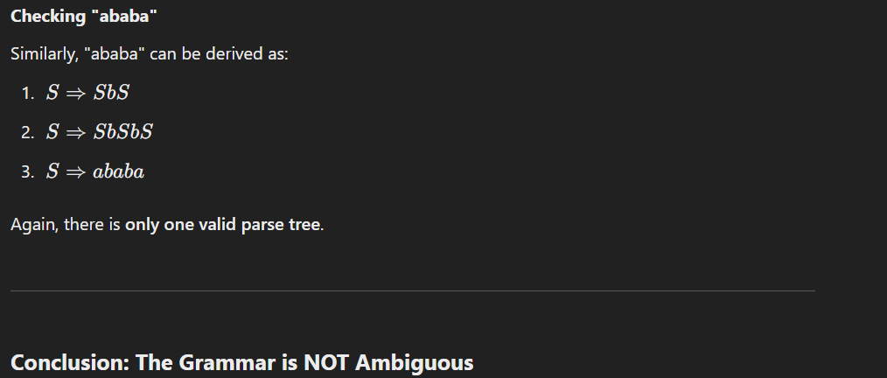



f) Show that grammar is ambiguous:

S → a | abSb | aAb A → bS | aAAb

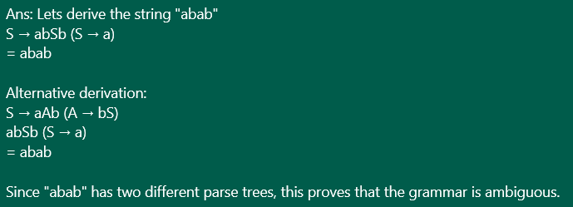

g) Show that grammar is ambiguous:

S → aB | ab A → aAB | a B → ABb | b

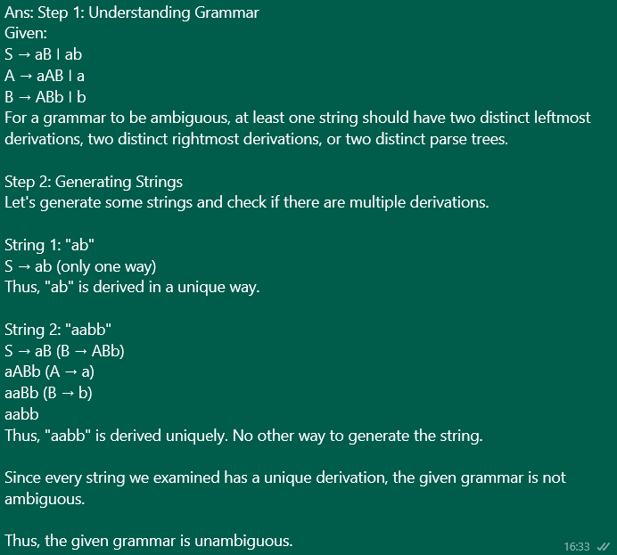



20. What are the applications of Pumping Lemma for Context Free Grammar.

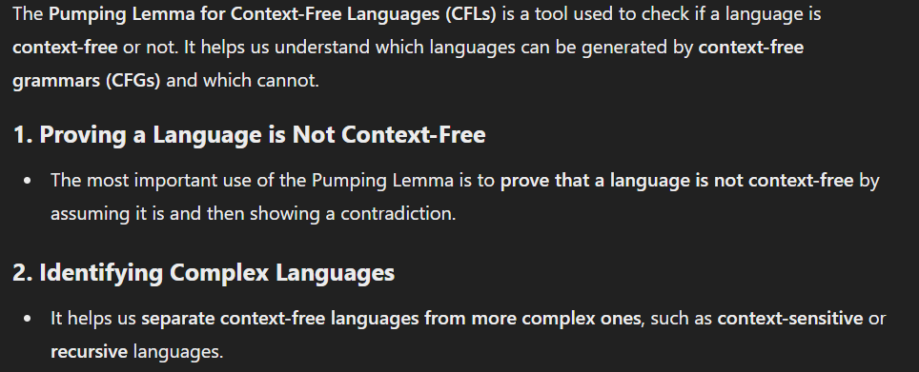

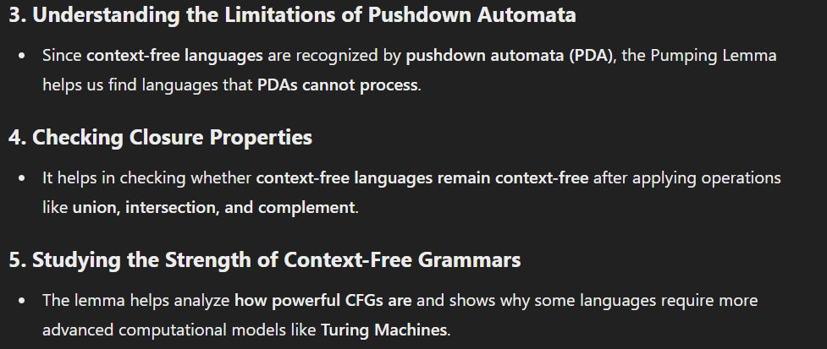

21. Define Pushdown Automata (PDA) and explain its components.

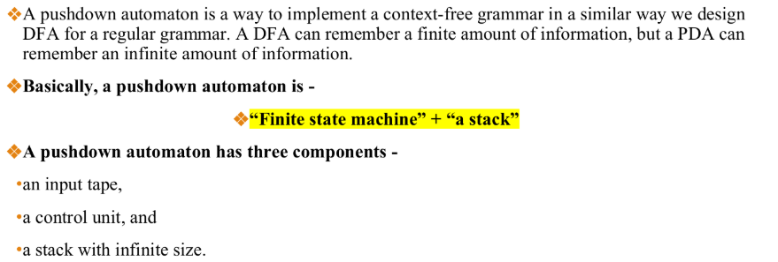

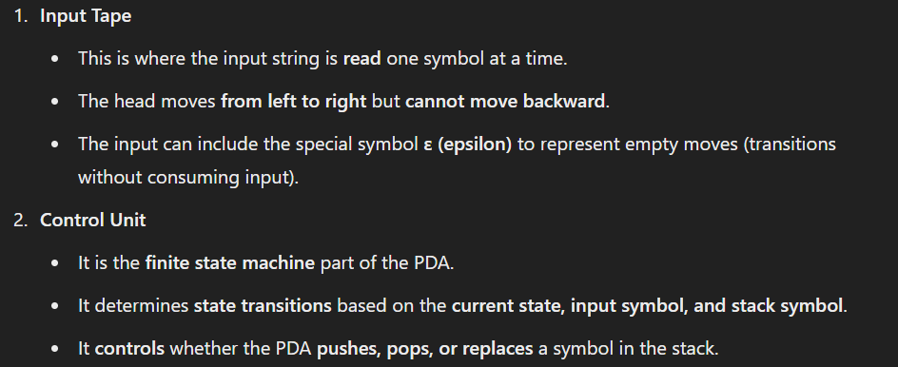

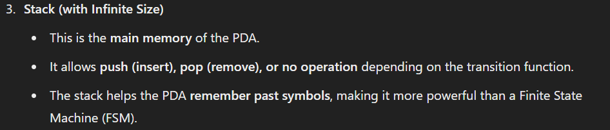

22. Describe the two types of Acceptance by PDA: Acceptance by final state and acceptance by empty stack.

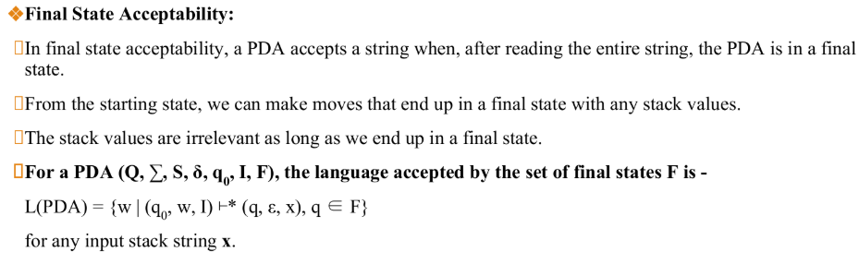

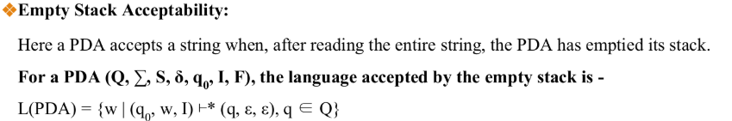

Empty Stack Acceptability Example :-

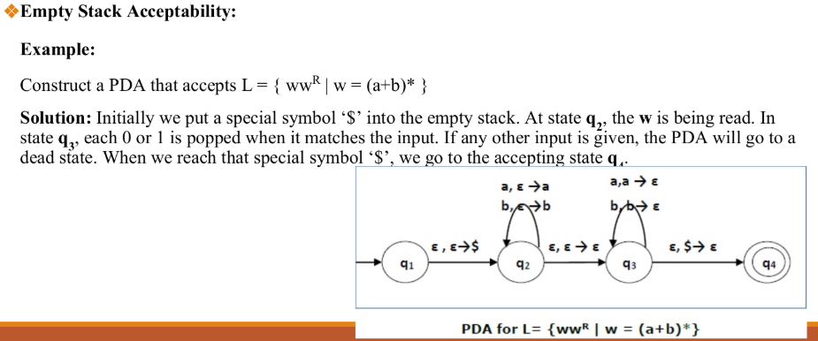

23. Explain the equivalence between PDA and CFG with an example.

24. Explain the formal description of PDA? What are the terminologies we use in PDA/Pushdown Automata.

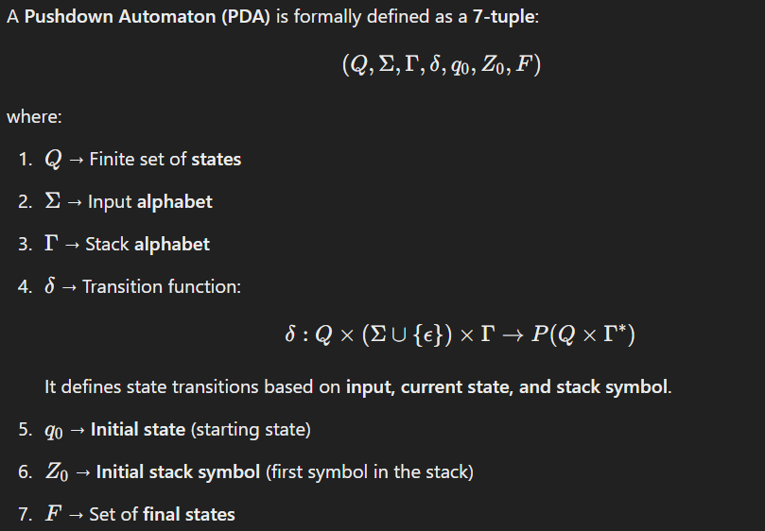

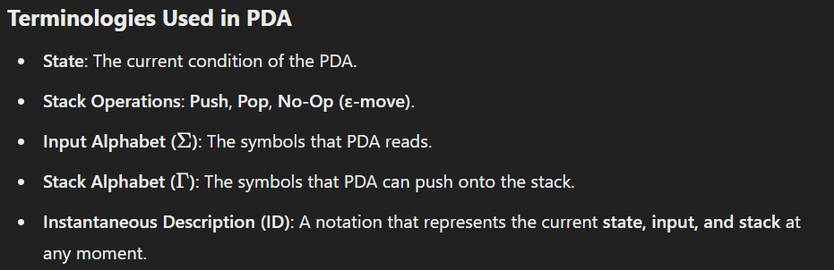

25. Define the following terms :-

a) PDA

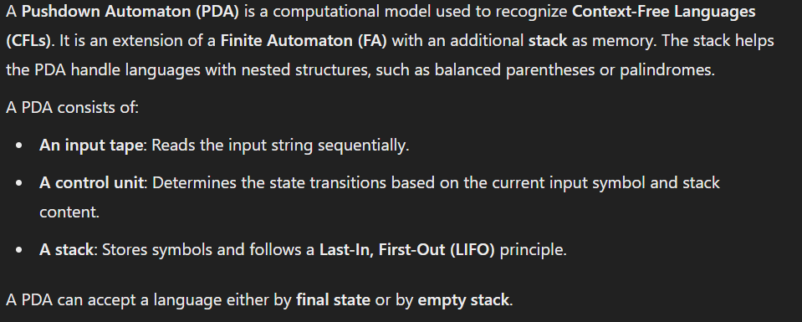



b) Instantaneous Description (ID)

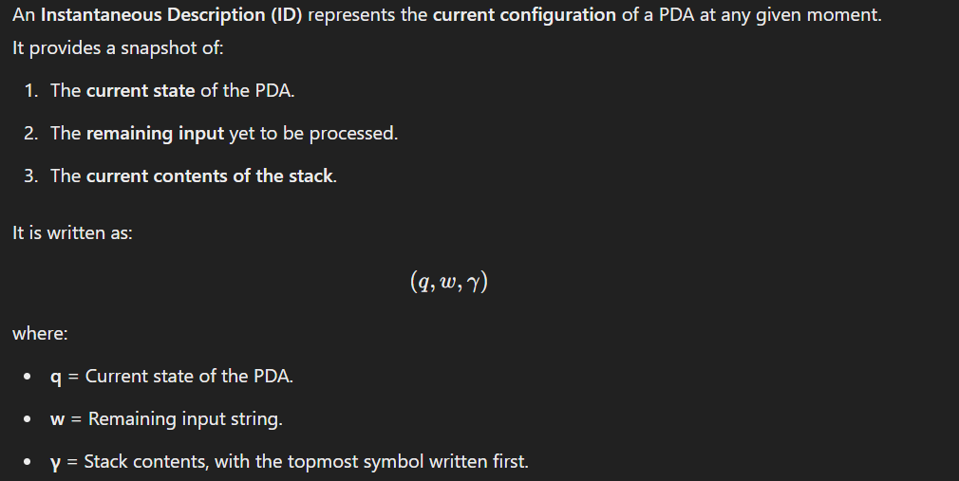

c) Turnstile Notation

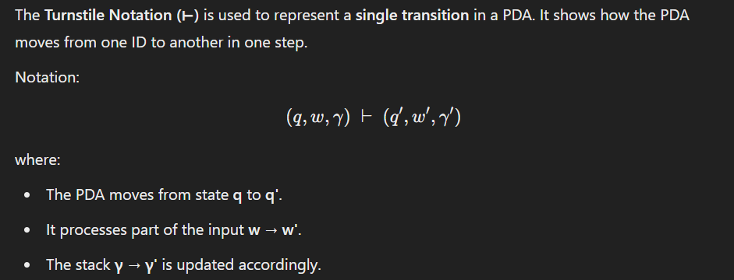

**TOC Unit 3**

1. Define a Linear Bounded Automaton (LBA) and explain how it differs from a Turing Machine.

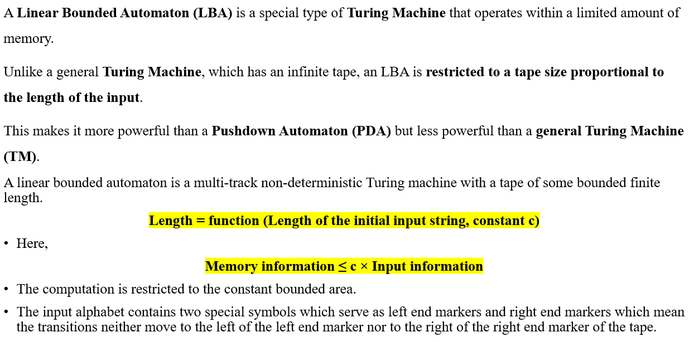

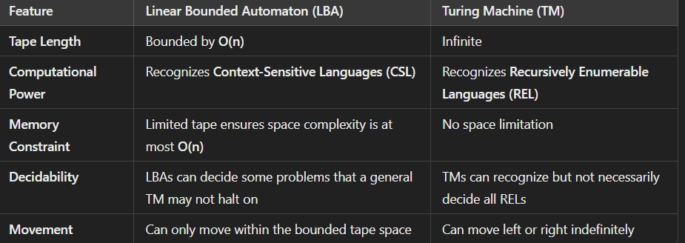

2. Describe the Linear Bounded Automata Model with a suitable example.



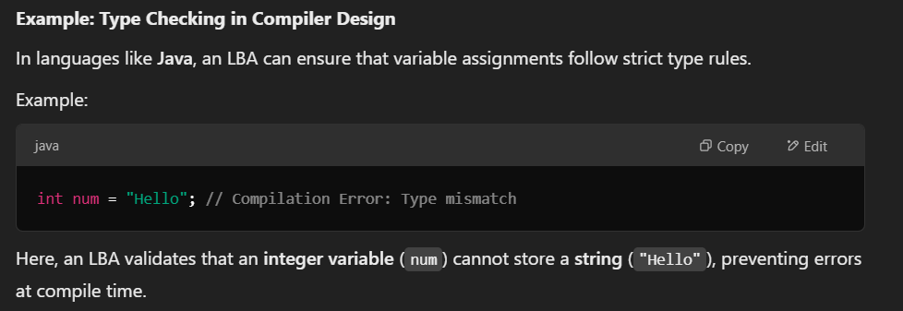

3. Explain the relationship between Linear Bounded Automata and Context-Sensitive Languages.

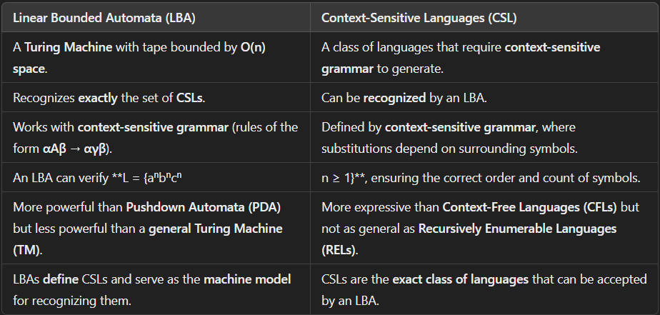

4. Define LBA? What are the properties of LBA.



Properties :-

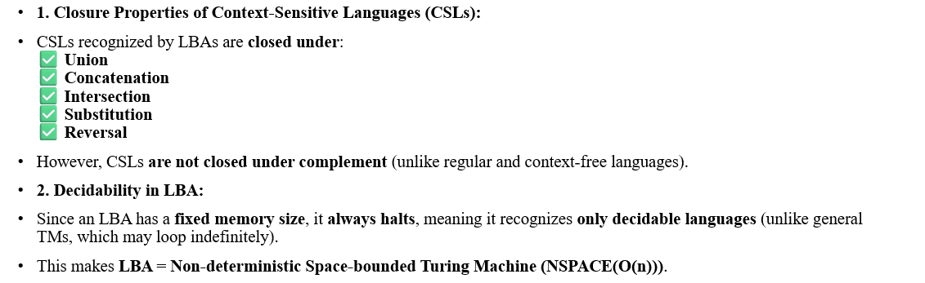

5. List the applications of LBA with suitable example.

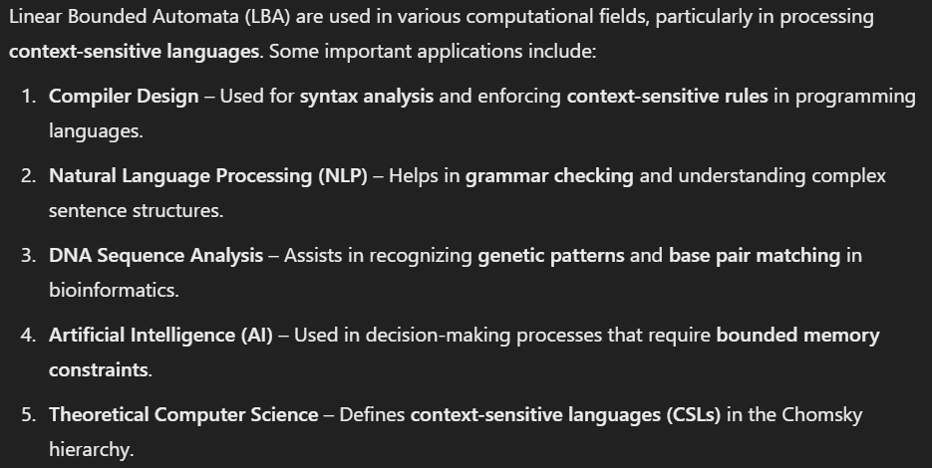

Example :-



6. What are the advantages and disadvantages of LBA?

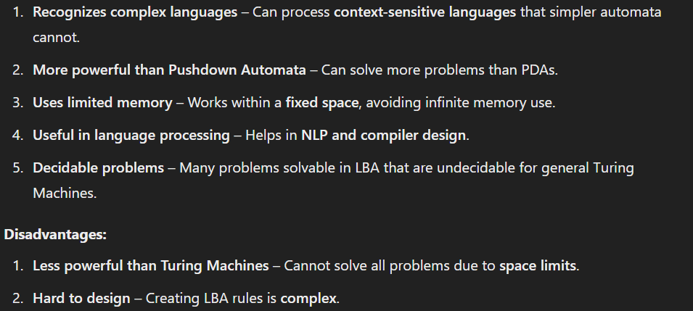

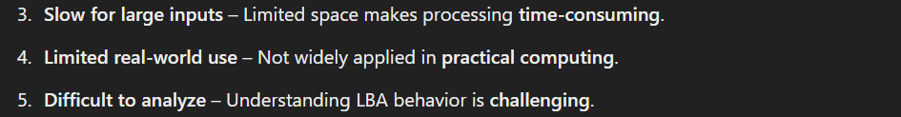

7. Define a Turing Machine and explain its components.

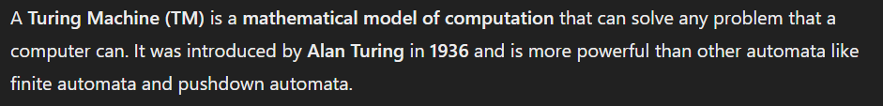

Components of Turing Machine are as follows :-

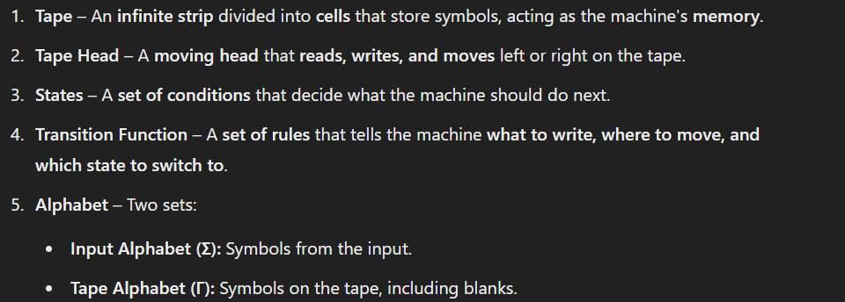

8. Describe different representations of a Turing Machine with examples.

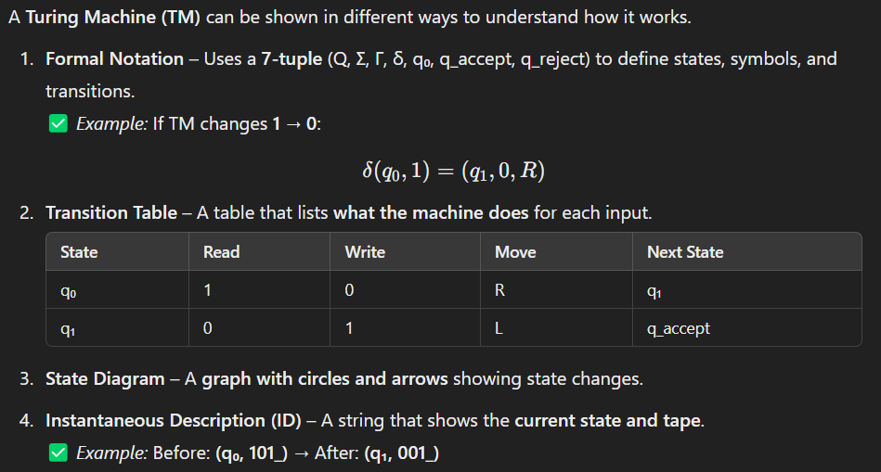





9. How does a Turing Machine determine the acceptability of a language?

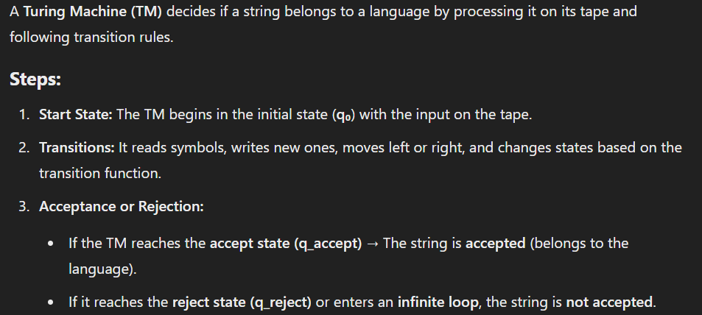

Example :-

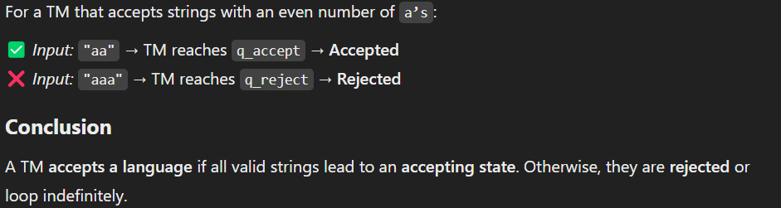

Conclusion :-



10. Outline the steps involved in designing and describing a Turing Machine.

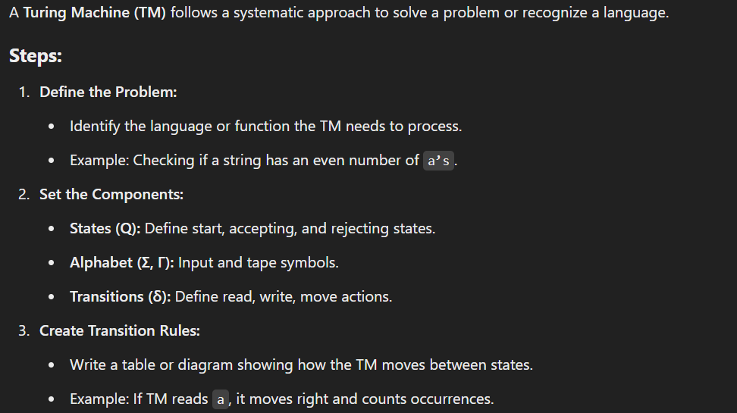





Example :-

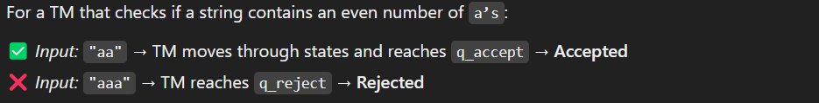

Conclusion :-



11. Explain different variants of Turing Machines and their significance.

Turing Machines have different versions, each useful for specific tasks in computation. The different types of variants are as follows :-

1. Multi-tape Turning Machine

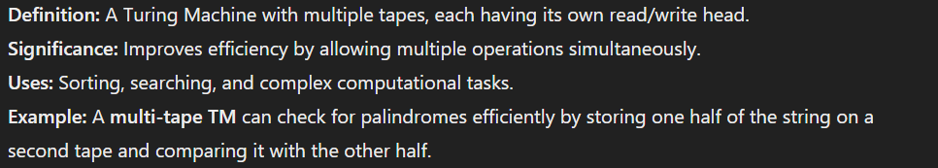

2. Non-Deterministic Turning Machine

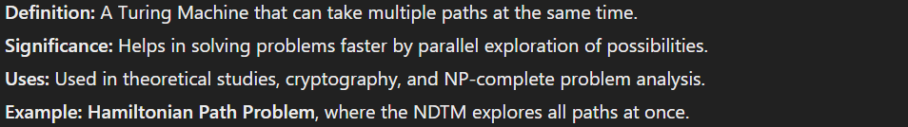

3. Multi-head Turning Machines

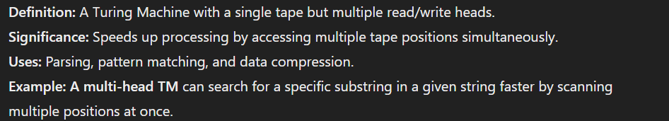

12. Explain the Turing Machine with its operation.

Definition :-



Components :-

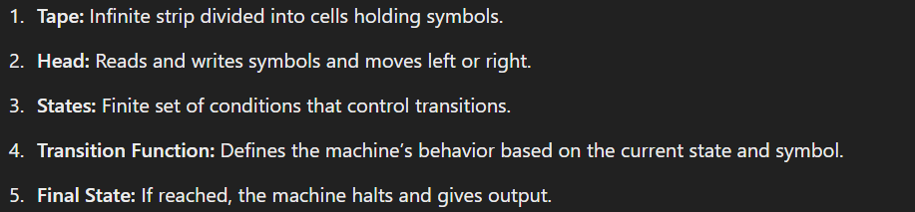

Operations :-

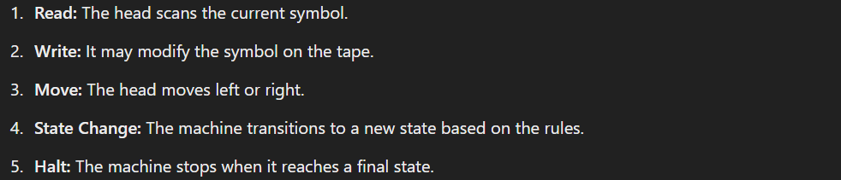

Example :-

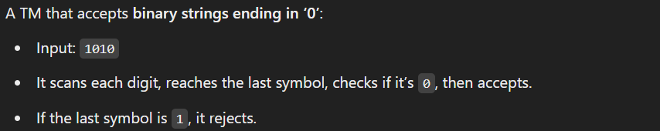

13. Write a short note on Turing Thesis in detail.

Definition :-

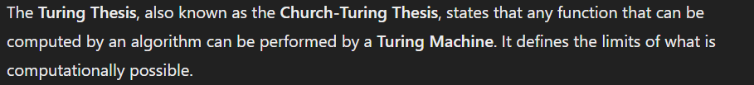

Key Idea :-



Singnificance :-

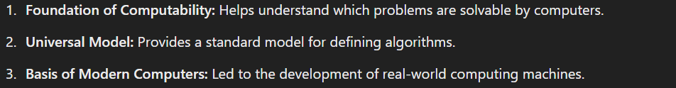

Uses :-



Example :-



14. List the applications of Turing Machine.

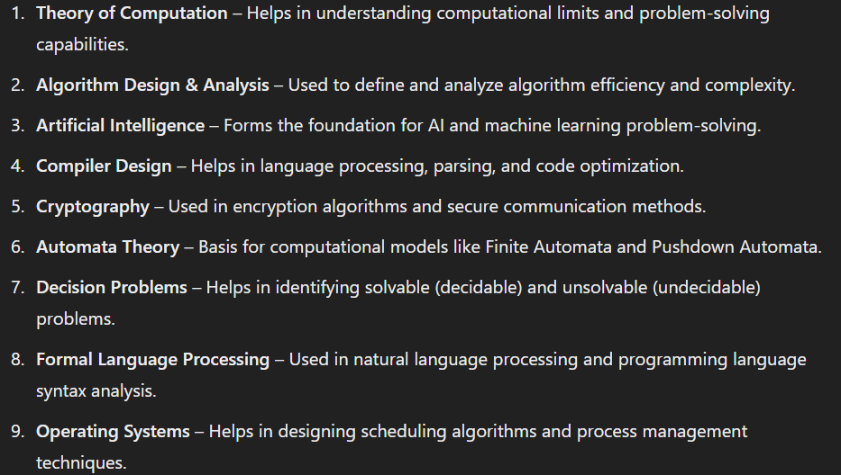



15. What are the advantages and disadvantages of Turing Machine.

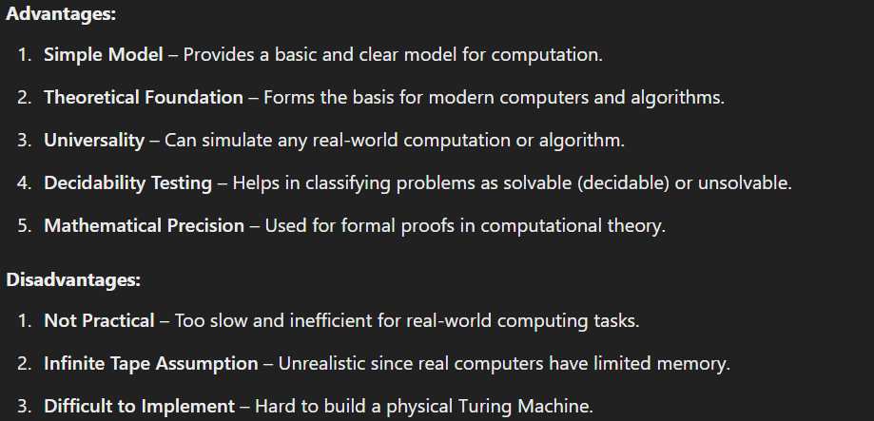

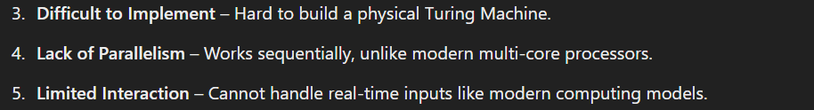

16. State and explain the Church-Turing Thesis.

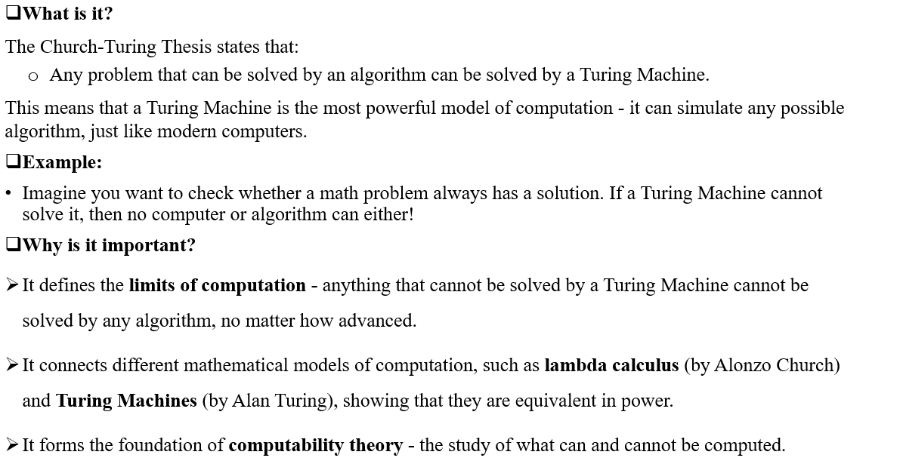

17. What is a Universal Turing Machine? How does it differ from a standard Turing Machine?

Definition :-

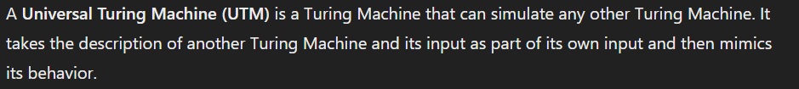

Difference from a standard Turing Machine :-

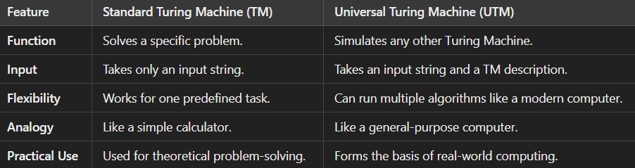

18. Explain the Halting Problem and why it is undecidable.

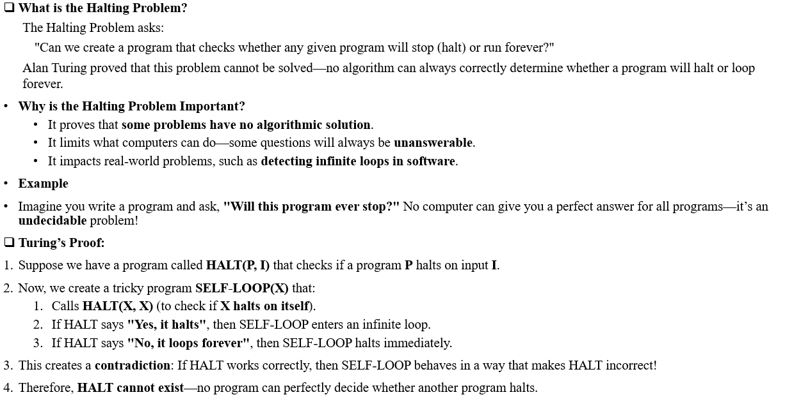



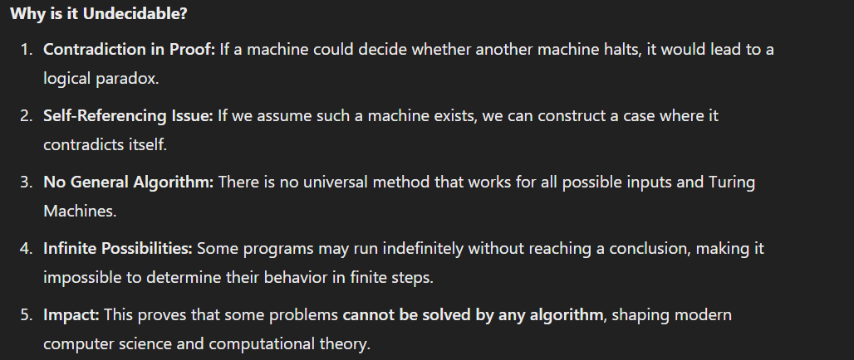

19. Give an example of an unsolvable problem and explain why it cannot be solved by a Turing Machine.

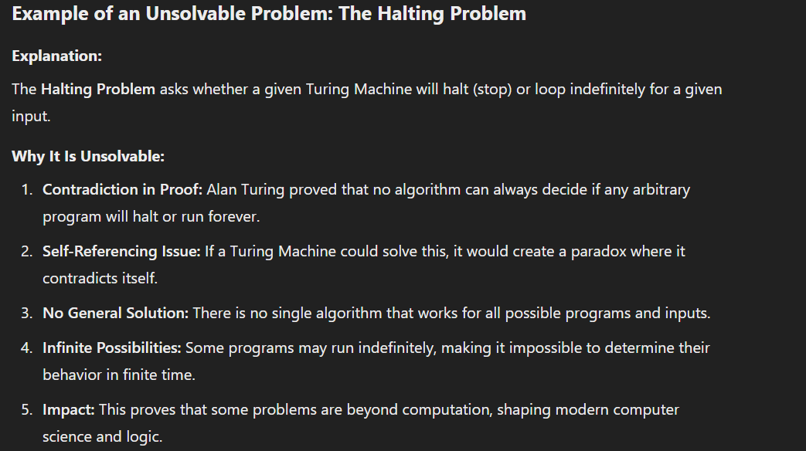

20. Define the following terms:

a. Multi-tape TM

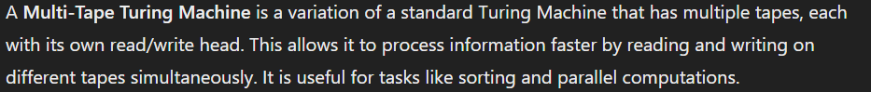

b. Non-Deterministic TM

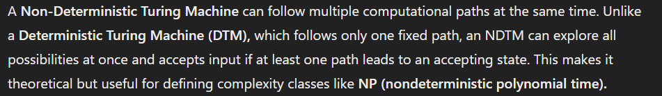

c. Multi-Head TM

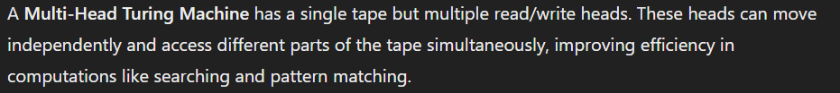

d. Off-line TM

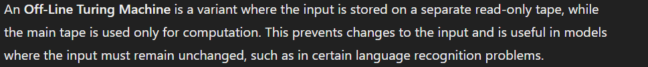

e. Turing Machine

